Question 1/4: Vectors (5 points)
Write a method void removeDuplicates() on the Vector class that traverses the vector and (in-place) removes all duplicates in it without creating or using an additional vector (or any other collections).
For example, after calling removeDuplicates() on the following vector:

[1, 2, 3, 3, 2, 4, 1]

will result in a vector containing the following elements:

[1, 2, 3, 4]

What is the time complexity of your algorithm?

- Question 2/4: Trees (6 points)
A different way to store a binary search tree than the method we have seen in class, is to store all the data in a vector. Every element in the tree corresponds to a position in the array, according to a fixed rule. The root is stored in the array on position 1, and for every element stored at position i, the left child is stored at position 2*i and the right child is stored at position 2*i+1.
For instance, for the tree on the left, the corresponding vector is given on the right
0 | 1 | 2 | 3 | 4 | 5 | 6 | 7 | 8 | 9 | 10 | 11 | 12 | 13 | 14
/ | 8 | 3 | 10 | 1 | 6 |  | 14 |  |  | 4 | 7 |  |  | 13
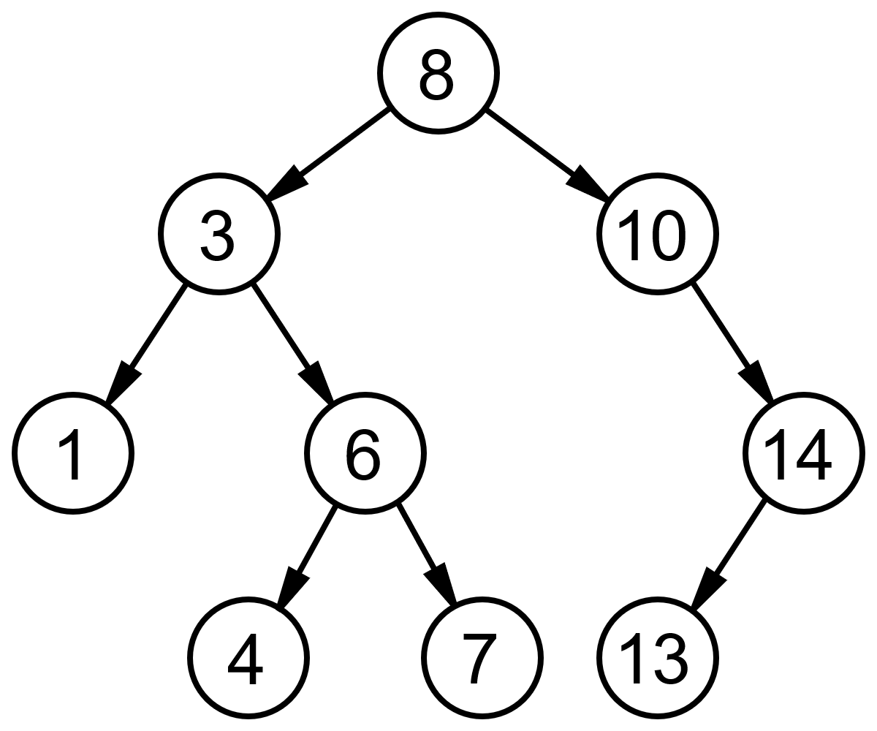

- Implement a method SetLeftChild(int index, Comparable value) which takes the index in the vector of the current node and assigns the given value to the left child.
- Two binary search trees are “element-equal” if they both store the same values, irrespective of the exact structure of the tree. Implement a method “element-equal” that checks whether both trees are storing exactly the same values. Implement this method on a binary search tree stored as a vector.
- What is time complexity of your method? Motivate.

Question 3/4 (4 points)
Assume a circular structure called Circular double linked list. This structure is similar to Double linked list, but the elements are chained in a circle, meaning the predecessor of the first element is the last element and the successor of the last element is the first element. Write the methods addFirst(...), addLast(), removeFirst(), removeLast() and contains(Object val).

Question 4/4: (5 points)
Consider a directed acyclic graph. A “transpose” of a graphs is the same graph, with all edges transposed, i.e. an edge from node i to node j is transposed into an edge from node j to node i. Write a transpose method on a graph in adjacency matrix representation. Motivate the time complexity of the method.

Provided Code

Linked List

public class LinkedList implements Comparable{
class ListElement
{
private Comparable el1;
private ListElement el2;

public ListElement(Comparable el, ListElement nextElement)
{
el1 = el;
el2 = nextElement;
}

public ListElement(Comparable el)
{
this(el,null);
}

public Comparable first()
{
return el1;
}

public ListElement rest()
{
return el2;
}

public void setFirst(Comparable value)
{
el1 = value;
}

public void setRest(ListElement value)
{
el2 = value;
}
}

protected ListElement head;
private int count = 0;

public LinkedList()
{
head = null;
}

public String toString()
{
String result = "(";
ListElement d = head;
while(d != null)
{
result += d.first().toString();
result += " ";
d = d.rest();
}
result += ")";
return result;
}
}

Stack
public class Stack {

private LinkedList data;

public Stack()
{
data = new LinkedList();
}

public void push(Comparable o)
{
data.addFirst(o);
}

public Comparable pop()
{
if(data.empty()) return null;
else return data.removeFirst();
}

public Comparable top()
{
return data.getFirst();
}

…
}

Binary Tree

public class Tree {

public class TreeNode implements Comparable {
protected Comparable value;
protected TreeNode leftNode, rightNode;
public TreeNode(Comparable v) {
value = v;
leftNode = null;
rightNode = null;
}
public TreeNode(Comparable v, TreeNode left, TreeNode right) {
value = v;
leftNode = left;
rightNode = right;
}
public TreeNode getLeftTree() { return leftNode; }

public TreeNode getRightTree() { return rightNode; }

public Comparable getValue() { return value; }
}
protected TreeNode root;
public Tree() {
root = null;
}
public void traverseNode(TreeNode n, TreeAction action) {
if(n != null) {
if(n.getLeftTree() != null) traverseNode(n.getLeftTree(),action);
action.run(n);
if(n.getRightTree() != null) traverseNode(n.getRightTree(),action);
}
}
public void traverseInOrder(TreeAction action) {
traverseNode(root,action);
}
public void traverse(TreeAction action){
Stack t = new Stack();
t.push(root);
while(!t.empty()) {
TreeNode n = (TreeNode)t.pop();
action.run(n);
if(n.getLeftTree() != null) t.push(n.getLeftTree());
if(n.getRightTree() != null) t.push(n.getRightTree());
}
}
}

Graph
public class Graph
{
public class Node implements Comparable
{
private Comparable info;
private Vector edges;

public Node(Comparable label)
{
info = label;
edges = new Vector();
}

public void addEdge(Edge e)
{
edges.addLast(e);
}

public int compareTo(Object o){ ... }

public Comparable getLabel()
{
return info;
}
}

private class Edge implements Comparable
{
private Node toNode;

public Edge(Node to)
{
toNode = to;
}

public int compareTo(Object o){ ... }
}

private Vector nodes;

public Graph()
{
nodes = new Vector();
}

public void addNode(Comparable label)
{
nodes.addLast(new Node(label));
}

public void addEdge(Comparable nodeLabel1, Comparable nodeLabel2)
{
Node n1 = findNode(nodeLabel1);
Node n2 = findNode(nodeLabel2);
n1.addEdge(new Edge(n2));
}
}

